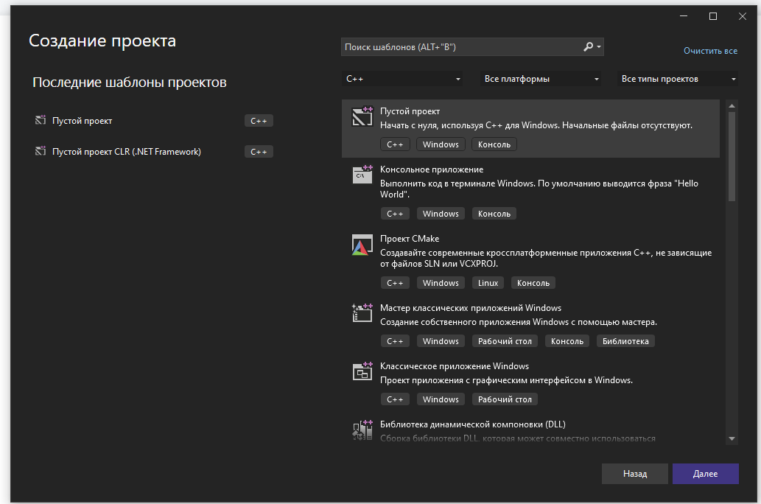

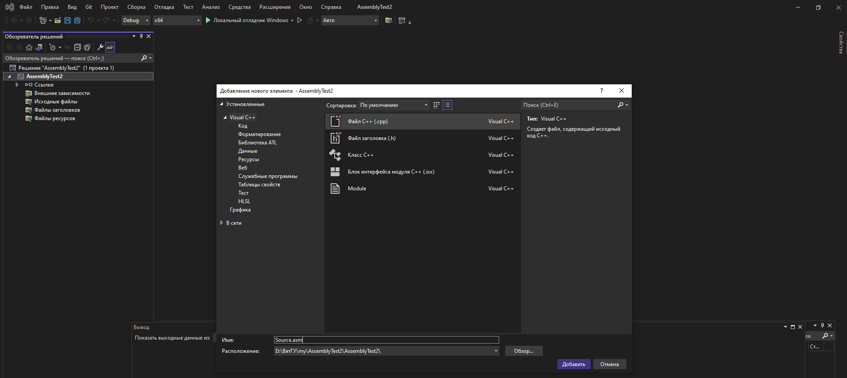

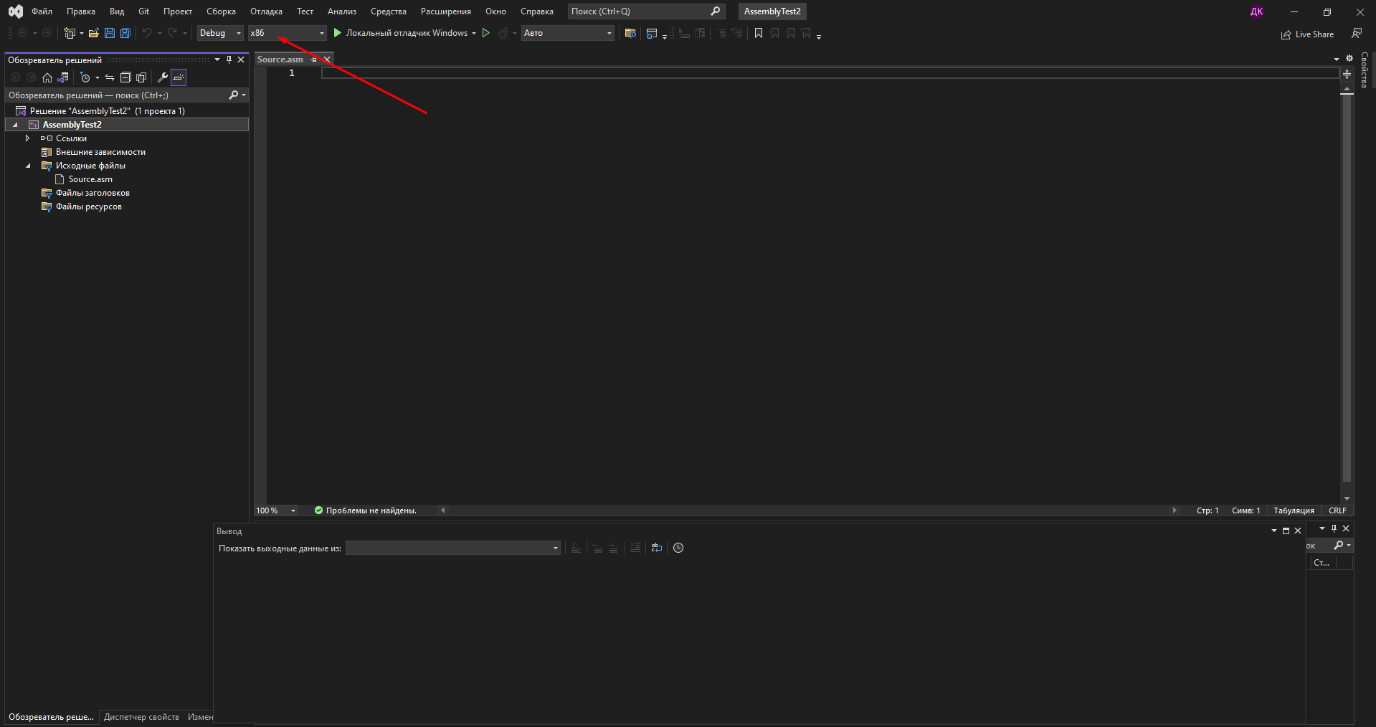

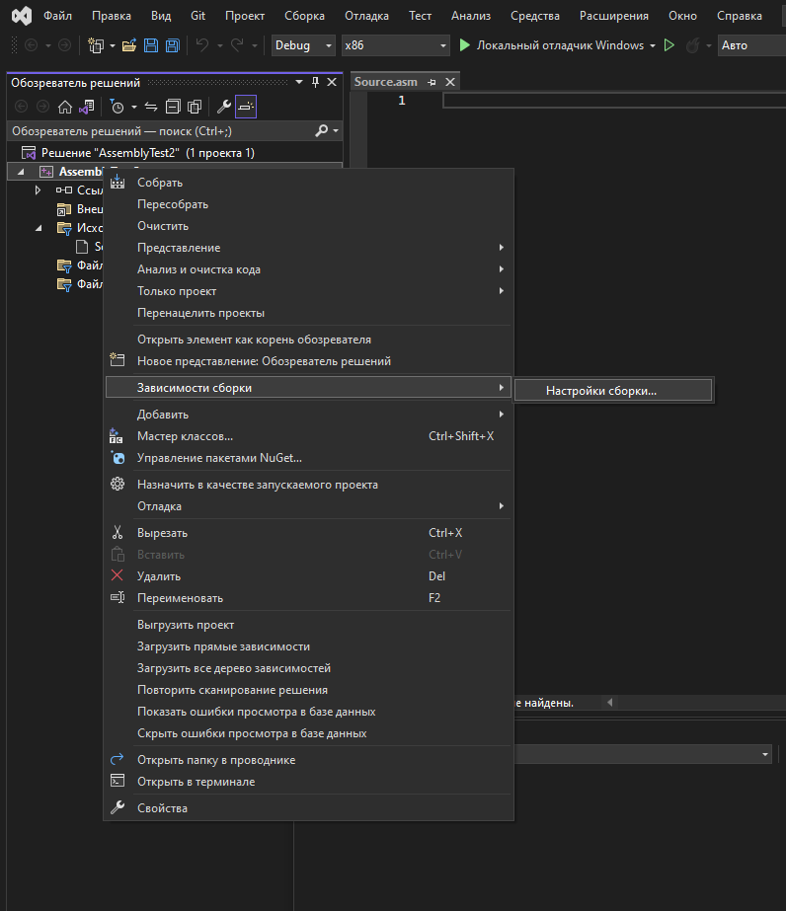

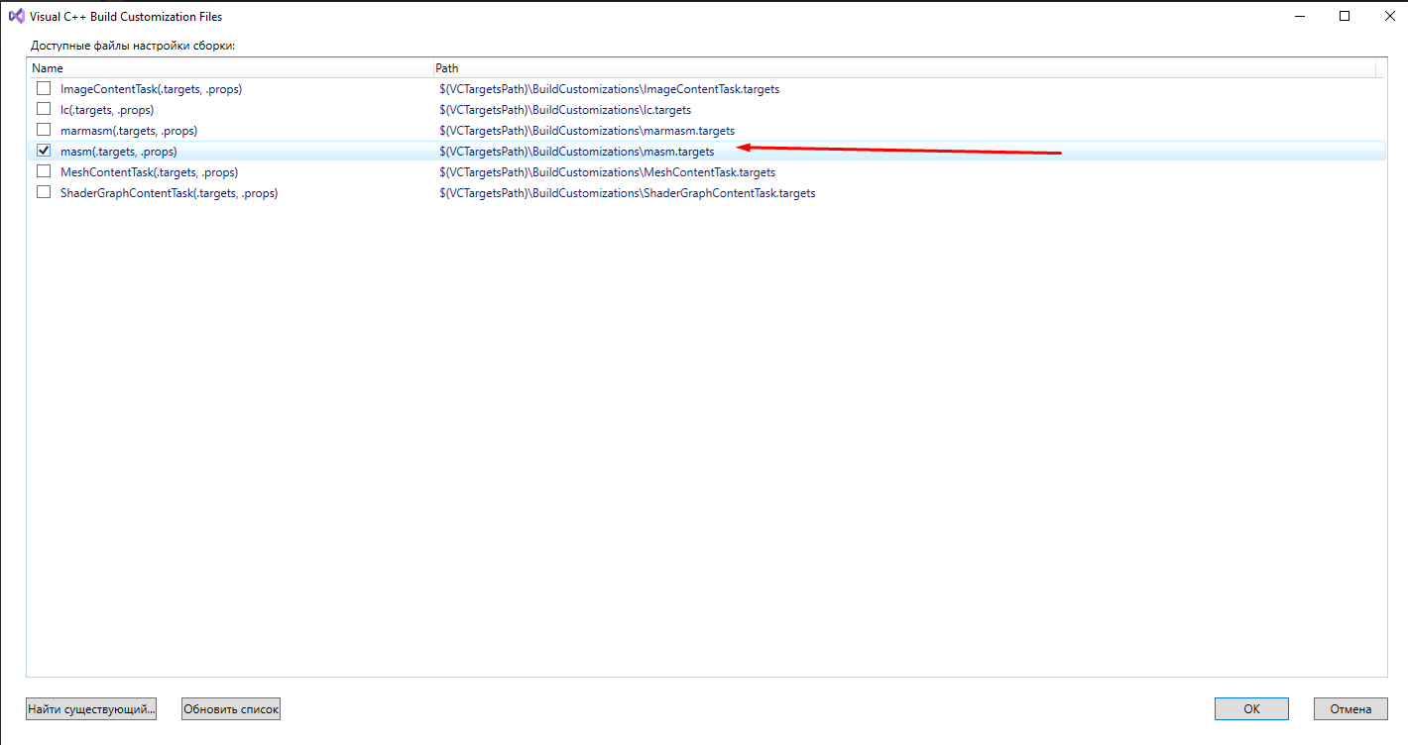

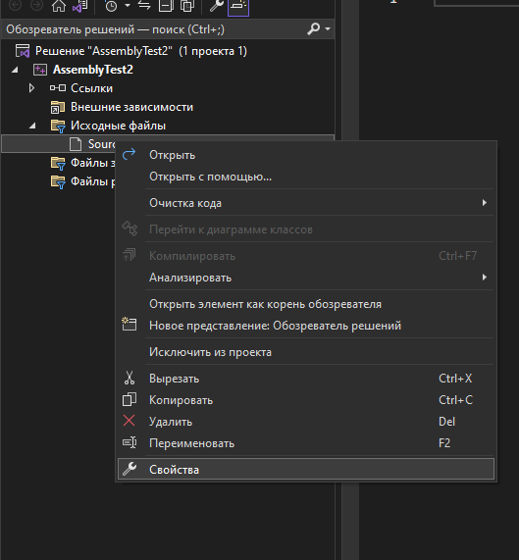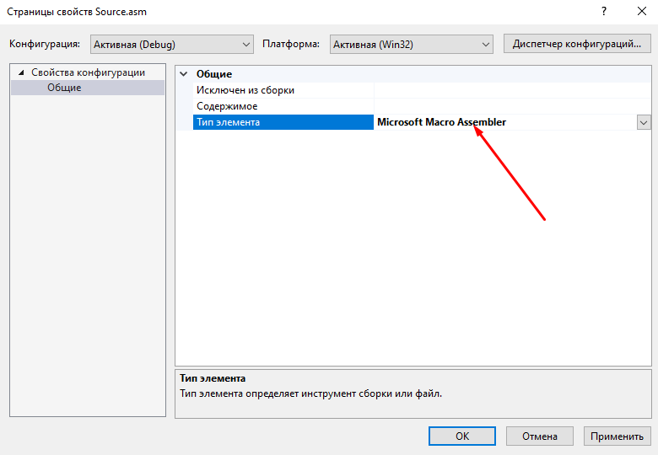

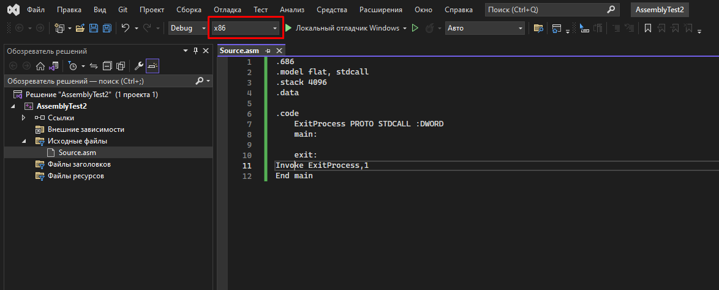

.686

.model flat, stdcall

.stack 4096

.data

.code

ExitProcess PROTO STDCALL :DWORD

main:

exit:

Invoke ExitProcess,1

End main

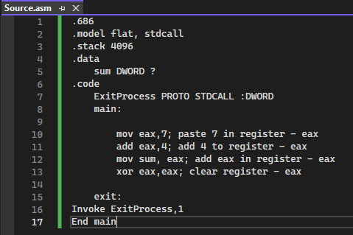

.686

.model flat, stdcall

.stack 4096

.data

sum DWORD ?

.code

ExitProcess PROTO STDCALL :DWORD

main:

mov eax,7; paste 7 in register - eax

add eax,4; add 4 to register - eax

mov sum, eax; add eax in register - eax

xor eax,eax; clear register - eax

exit:

Invoke ExitProcess,1

End main

